Configuring Basic Single Area OSPF:Passive Interfaces

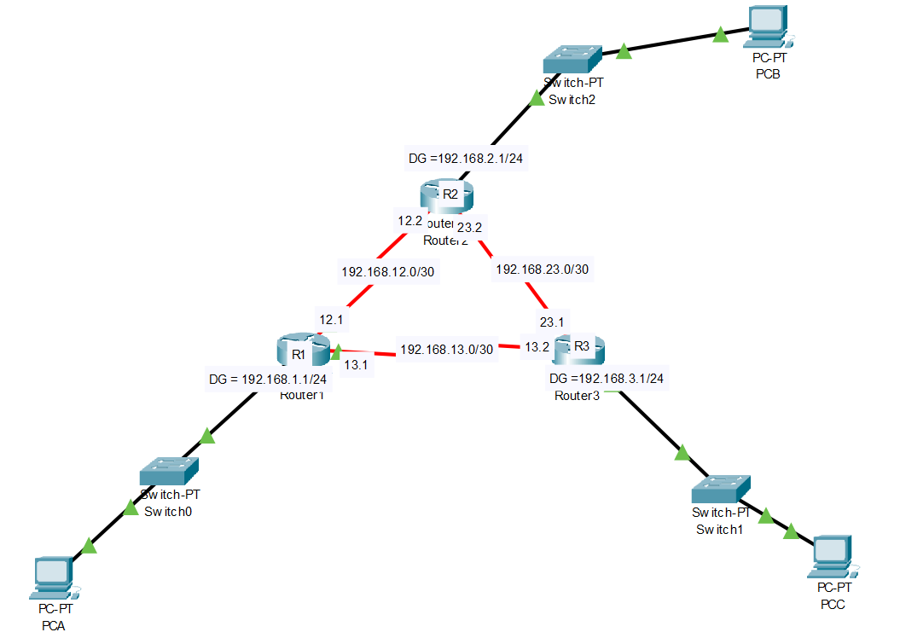

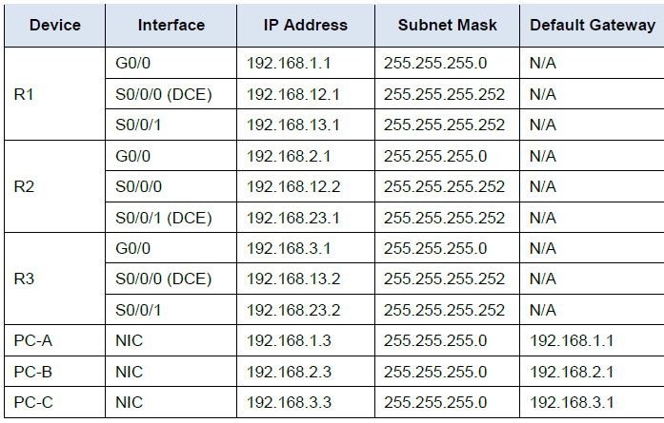
Test connectivity

The routers should be able to ping one another, and each PC should be able to ping its default gateway. The PCs are unable to ping other PCs until OSPF routing is configured. Verify and troubleshoot if necessary.

Configure OSPF Passive Interfaces

The passive-interface command prevents routing updates from being sent through the specified router interface. This is commonly done to reduce traffic on the LANs as they do not need to receive dynamic routing protocol communication.

In Part 1, you will use the passive-interface command to configure a single interface as passive. You will also configure OSPF so that all interfaces on the router are passive by default, and then enable OSPF routing advertisements on selected interfaces.

Step 1: Configure a passive interface

- Issue the show ip ospf interface Fa0/0 command on R1. Notice the timer indicating when the next Hello packet is expected.
Hello packets are sent every 10 seconds and are used between OSPF routers to verify that their neighbors are up.

R1# show ip ospf interface Fa0/0

GigabitEthernet0/0 is up, line protocol is up
Internet Address 192.168.1.1/24, Area 0, Attached via Network Statement
Process ID 1, Router ID 11.11.11.11, Network Type BROADCAST, Cost: 1
Topology-MTID Cost Disabled Shutdown Topology Name
0 1 no no Base
Transmit Delay is 1 sec, State DR, Priority 1
Designated Router (ID) 11.11.11.11, Interface address 192.168.1.1
No backup designated router on this network
Timer intervals configured, Hello 10, Dead 40, Wait 40, Retransmit 5
resync timeout 40
Hello due in 00:00:02
Supports Link-local Signaling (LLS)
Cisco NSF helper support enabled
IETF NSF helper support enabled
Index 1/1, flood queue length 0
Next 0x0(0)/0x0(0)
Last flood scan length is 0, maximum is 0
Last flood scan time is 0 msec, maximum is 0 msec
Neighbor Count is 0, Adjacent neighbor count is 0
Suppress hello for 0 neighbor(s)

b. Issue the passive-interface command to change the Fa0/0 interface on R1 to passive.

R1(config)# router ospf 1
R1(config-router)# passive-interface fa0/0

c. Re-issue the show ip ospf interface Fa0/0 command to verify that Fa0/0 is now passive.

R1# show ip ospf interface Fa0/0
GigabitEthernet0/0 is up, line protocol is up
Internet Address 192.168.1.1/24, Area 0, Attached via Network Statement
Process ID 1, Router ID 11.11.11.11, Network Type BROADCAST, Cost: 1
Topology-MTID Cost Disabled Shutdown Topology Name
0 1 no no Base
Transmit Delay is 1 sec, State DR, Priority 1
Designated Router (ID) 11.11.11.11, Interface address 192.168.1.1
No backup designated router on this network
Timer intervals configured, Hello 10, Dead 40, Wait 40, Retransmit 5
oob-resync timeout 40
No Hellos (Passive interface)
Supports Link-local Signaling (LLS)
Cisco NSF helper support enabled
IETF NSF helper support enabled
Index 1/1, flood queue length 0
Next 0x0(0)/0x0(0)
Last flood scan length is 0, maximum is 0
Last flood scan time is 0 msec, maximum is 0 msec
Neighbor Count is 0, Adjacent neighbor count is 0
Suppress hello for 0 neighbor(s)

d. Issue the show ip route command on R2 and R3 to verify that a route to the 192.168.1.0/24 network is still available.

R2# show ip route
Codes: L - local, C - connected, S - static, R - RIP, M - mobile, B - BGP
D - EIGRP, EX - EIGRP external, O - OSPF, IA - OSPF inter area
N1 - OSPF NSSA external type 1, N2 - OSPF NSSA external type 2
E1 - OSPF external type 1, E2 - OSPF external type 2
i - IS-IS, su - IS-IS summary, L1 - IS-IS level-1, L2 - IS-IS level-2
ia - IS-IS inter area, * - candidate default, U - per-user static route
o - ODR, P - periodic downloaded static route, H - NHRP, l - LISP
+ - replicated route, % - next hop override
Gateway of last resort is not set

2.0.0.0/32 is subnetted, 1 subnets
C 2.2.2.2 is directly connected, Loopback0
O 192.168.1.0/24 [110/65] via 192.168.12.1, 00:58:32, Serial0/0/0
192.168.2.0/24 is variably subnetted, 2 subnets, 2 masks
C 192.168.2.0/24 is directly connected, GigabitEthernet0/0
L 192.168.2.1/32 is directly connected, GigabitEthernet0/0
O 192.168.3.0/24 [110/65] via 192.168.23.2, 00:58:19, Serial0/0/1
192.168.12.0/24 is variably subnetted, 2 subnets, 2 masks
C 192.168.12.0/30 is directly connected, Serial0/0/0
L 192.168.12.2/32 is directly connected, Serial0/0/0
192.168.13.0/30 is subnetted, 1 subnets
O 192.168.13.0 [110/128] via 192.168.23.2, 00:58:19, Serial0/0/1
[110/128] via 192.168.12.1, 00:58:32, Serial0/0/0
192.168.23.0/24 is variably subnetted, 2 subnets, 2 masks
C 192.168.23.0/30 is directly connected, Serial0/0/1
L 192.168.23.1/32 is directly connected, Serial0/0/1

Step 2: Set passive interface as the default on a router

a. Issue the show ip ospf neighbor command on R1 to verify that R2 is listed as an OSPF neighbor.

R1# show ip ospf neighbour

Neighbor ID Pri State Dead Time Address Interface
33.33.33.33 0 FULL/ - 00:00:31 192.168.13.2 Serial0/0/1
22.22.22.22 0 FULL/ - 00:00:32 192.168.12.2 Serial0/0/0

b. Issue the passive-interface default command on R2 to set the default for all OSPF interfaces as passive.

R2(config)# router ospf 1
R2(config-router)# passive-interface default
R2(config-router)#
*Apr 3 00:03:00.979: %OSPF-5-ADJCHG: Process 1, Nbr 11.11.11.11 on Serial0/0/0 from FULL to DOWN, Neighbor Down: Interface down or detached
*Apr 3 00:03:00.979: %OSPF-5-ADJCHG: Process 1, Nbr 33.33.33.33 on Serial0/0/1 from FULL to DOWN, Neighbor Down: Interface down or detached

c. Re-issue the show ip ospf neighbor command on R1. After the dead timer expires, R2 will no longer be listed as an OSPF neighbor.

R1# show ip ospf neighbor
Neighbor ID Pri State Dead Time Address Interface
33.33.33.33 0 FULL/ - 00:00:34 192.168.13.2 Serial0/0/1

d. Issue the show ip ospf interface S0/0/0 command on R2 to view the OSPF status of interface S0/0/0.

R2# show ip ospf interface s0/0/0
Serial0/0/0 is up, line protocol is up
Internet Address 192.168.12.2/30, Area 0, Attached via Network Statement
Process ID 1, Router ID 22.22.22.22, Network Type POINT_TO_POINT, Cost: 64
Topology-MTID Cost Disabled Shutdown Topology Name
0 64 no no Base
Transmit Delay is 1 sec, State POINT_TO_POINT
Timer intervals configured, Hello 10, Dead 40, Wait 40, Retransmit 5
oob-resync timeout 40
No Hellos (Passive interface)
Supports Link-local Signaling (LLS)
Cisco NSF helper support enabled
IETF NSF helper support enabled
Index 2/2, flood queue length 0
Next 0x0(0)/0x0(0)
Last flood scan length is 0, maximum is 0
Last flood scan time is 0 msec, maximum is 0 msec
Neighbor Count is 0, Adjacent neighbor count is 0
Suppress hello for 0 neighbor(s)

e. If all interfaces on R2 are passive, then no routing information is being advertised. In this case, R1 and R3 should no longer have a route to the 192.168.2.0/24 network. You can verify this by using the show ip route command.

f. On R2, issue the no passive-interface command so the router will send and receive OSPF routing updates. After entering this command, you will see an informational message that a neighbor adjacency has been established with R1.

R2(config)# router ospf 1
R2(config-router)# no passive-interface s0/0/0
R2(config-router)#
*Apr 3 00:18:03.463: %OSPF-5-ADJCHG: Process 1, Nbr 11.11.11.11 on Serial0/0/0 from loading to full loading

g. Re-issue the show ip route and show ip ospf neighbor commands on R1 and R3, and look for a route to the 192.168.2.0/24 network.

What interface is R3 using to route to the 192.168.2.0/24 network?

What is the accumulated cost metric for the 192.168.2.0/24 network on R3?

Does R2 show up as an OSPF neighbor on R1?

Does R2 show up as an OSPF neighbor on R3?

What does this information tell you?

h. Change interface S0/0/1 on R2 to allow it to advertise OSPF routes. Record the commands used below.

i. Re-issue the show ip route command on R3.

What interface is R3 using to route to the 192.168.2.0/24 network?
What is the accumulated cost metric for the 192.168.2.0/24 network on R3 now and how is this calculated?

Is R2 listed as an OSPF neighbor to R3?

